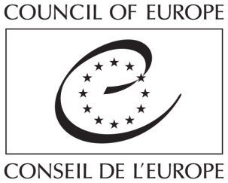

Seminar on the
« Role of NGOs in the Remembrance of the Holocaust »
Krakow, Auschwitz- Birkenau
22-28 October 2017

APPLICATION FORM/
FORMULAIRE D’INSCRIPTION

Please complete this form in English, in CAPITAL LETTERS, and return it
not later than 18 September 2017
to holocaust@coe.int and to mireille.wendling@coe.int

Applicant: Mr. /M. ▢ Ms./ Mme ▢
Surname: ____________________________________
First Name: ____________________________________
Age Group: ▢ 25-35 ▢ 35-45 ▢ 45-55 ▢ 55-65 ▢ other/autres
Nationality: __________________________

Special needs: ▢ Diet/ régime alimentaire (please precise/ merci de préciser)
▢ Other/ Autres (please precise/ merci de préciser)
Postal address: ____________________________________________
____________________________________________

E-mail: _____________________________
YOUR NGO

Name of your NGO: _________________________________________________

Main activities: __________________________________________________

___________________________________________________

Position within your organisation: _____________________________________

What are the links between your NGO and the “Remembrance of the Holocaust“ ?
_______________________________________________________________________
_______________________________________________________________________

WORKING LANGUAGE/ LANGUE DE TRAVAIL

I certify that my level of knowledge in English is/ Je certifie que mon niveau d’anglais est :
Understanding/ Compréhension: ▢ Very Good/ Très bien ▢ Good/ Bien
Speaking/ Parlé: ▢ Very Good/ Très bien ▢ Good/ Bien

MOTIVATION FOR APPLYING/ MOTIVATION A POSTULER

Why are you applying for this training course ?
_______________________________________________________________________
_______________________________________________________________________

What do you expected from this course ?
_______________________________________________________________________
_______________________________________________________________________

